Since 2013, the City of Brawley is regulated by the State Water Resources Control Board as a Traditional Small MS4 and thus required to comply with the State’s General Permit for Waste Discharge Requirement (WDRs) for Storm Water Discharges from small municipal separate storm sewer systems (MS4s).
According to Section E.12 of permit
(https://www.waterboards.ca.gov/board_decisions/adopted_orders/water_quality/2013/wqo2013_0001dwq.pdf) , projects creating or replacing more than 5000 sf of impervious area shall be considered as “Regulated Projects” must incorporate post-construction water quality measures in accordance with the State's Phase II Small MS4 Permit at https://www.waterboards.ca.gov/water_issues/programs/stormwater/phase_ii_municipal.html
Please refer to the order WQ 2013-0001-DWQ (Adopted 2/5/2013)) for additional information regarding requirements for "regulated projects". Some relevant information is summarized below.
Regulated projects are required to implement water quality best management practices to treat storm water runoff by providing a water quality management plan addressing the following items.
  - Site Design measures.
  - Source Control Measures.
  - Numeric Sizing for Storm Water Retention and Treatment. (Can use the State’s CA Phase II LID Sizing Tool – v1.2 for this requirement. https://www.owp.csus.edu/LIDTool/)
  - Storm Water Treatment Measures and Baseline Hydromodification Measures.
  - Hydromodification Management Narrative and Analysis
  - An Operations and Maintenance plan for any structural water quality treatment BMPs proposed, which included maintenance activities and frequencies of these activities, and responsible parties for long-term maintenance.
  - A signed and stamped certification statement by a Registered Civil Engineer, State of California.
Regulated projects CANNOT be piecemealed so as to avoid water quality triggers. Projects that are a part of a larger development are NOT exempt from complying with water quality. Please see language from the permit detailing this.
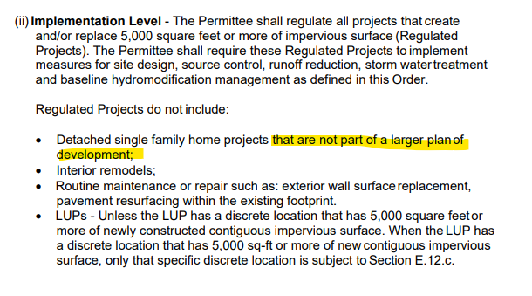
Disclaimer: The City Engineer reserves the right to determine if a project qualifies as part of a larger development/project.

